
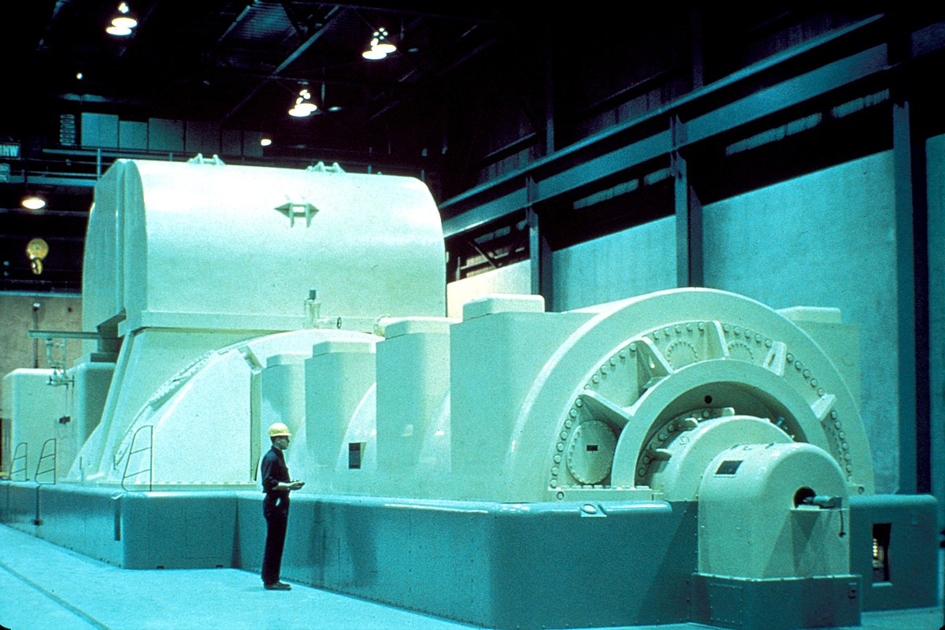
TOPIC
INDEX
Making an AC Generator
By using the concept of
electromagnetic
induction.

